



****

****

****

Figure 5. Plots of the linear relationships between the median expected number of species (black line or black point) belonging to each guild (see Appendix A for guild designations and associated forest songbird species) and the predictor variables, which consisted of year, elevation, mean breeding season (i.e., 15 May to 30 June) temperature during the year of data collection (Mean Temperature), standard deviation of breeding season temperature (SD Temperature), total breeding season precipitation during the year of data collection (Current Precipitation), total breeding season precipitation during the previous year (Previous Precipitation), dominant forest type within 50 m (Dominant Forest Type, where 0 = non-deciduous forest and 1 = deciduous forest), and proportion of any type of forest cover within 1 km (Proportion Forest). The gray shading or black whiskers indicate 95% credible intervals. The continuous predictor variables are centered and scaled, such that zero is the mean value, and reflect the range of the data. Bolded predictor variables have statistically significant slope coefficients (i.e., credible intervals do not overlap zero).

































Figure 6. Plots of the linear relationships between the median expected count (i.e., abundance; portrayed by the black line or black point) for each of the focal species (Table 1) and the predictor variables, which consisted of year, elevation, aspect, topographic position index (TPI), mean breeding season (i.e., 15 May to 30 June) temperature during the year of data collection (Mean Temperature), standard deviation of breeding season temperature (SD Temperature), total breeding season precipitation during the year of data collection (Current Precipitation), total breeding season precipitation during the previous year (Previous Precipitation), dominant forest type within 50 m (Dominant Forest Type, where 0 = non-deciduous forest and 1 = deciduous forest), and proportion of any type of forest cover within 1 km (Proportion Forest). The gray shading or black whiskers indicate 95% credible intervals. The continuous predictor variables are centered and scaled, such that zero is the mean value, and reflect the range of the data. Bolded predictor variables have statistically significant slope coefficients (i.e., credible intervals do not overlap zero). Color of the 4-letter species code indicates its guild designation (dark blue = north guild, red = south guild, light blue = trailing guild, and orange = general guild), and the bird silhouette indicates its taxonomic family (warbler, thrush, or flycatcher).











Figure 7. Plots of the effects of the two-way interactions between an index of latitude and the other predictor variables of interest (Table 2) on the median expected number of species (black line) belonging to each guild (see Appendix A for guild designations and associated forest songbird species), with 95% credible intervals (gray shading). The predictor variables are centered and scaled, such that zero is the mean value, and reflect the range of the data. Because mean breeding season (i.e., 15 May to 30 June) temperature during the year of data collection was highly correlated with latitude, it was used as an index such that the north, central, and south plots correspond to the mean breeding season temperatures across all sampling points in the Hubbard Brook Experimental Forest (14.3°C), Monongahela National Forest (16.3°C), and the 2 North Carolina National Forests (18.6°C), respectively.

































Figure 8. Plots of the effects of the two-way interactions between an index of latitude (left) or elevation (right) and the other predictor variables of interest (Table 2) on the median expected count (i.e., abundance; portrayed by black line) for each of the focal species (Table 1), with 95% credible intervals (gray shading). The predictor variables are centered and scaled, such that zero is the mean value, and reflect the range of the data. Because mean breeding season (i.e., 15 May to 30 June) temperature during the year of data collection was highly correlated with latitude, it was used as an index such that the north, central, and south plots correspond to the mean breeding season temperatures across all sampling points in the Hubbard Brook Experimental Forest (14.3°C), Monongahela National Forest (16.3°C), and the 2 North Carolina National Forests (18.6°C), respectively. Low, mid, and high elevation (elev) plots correspond respectively to 585.8 m, 844.3 m, and 1214.3 m, which are the 15th, 50th, and 85th percentiles of the elevation data across all sampling points. Color of the 4-letter species code indicates its guild designation (dark blue = north guild, red = south guild, light blue = trailing guild, and orange = general guild), and the bird silhouette indicates its taxonomic family (warbler, thrush, or flycatcher).

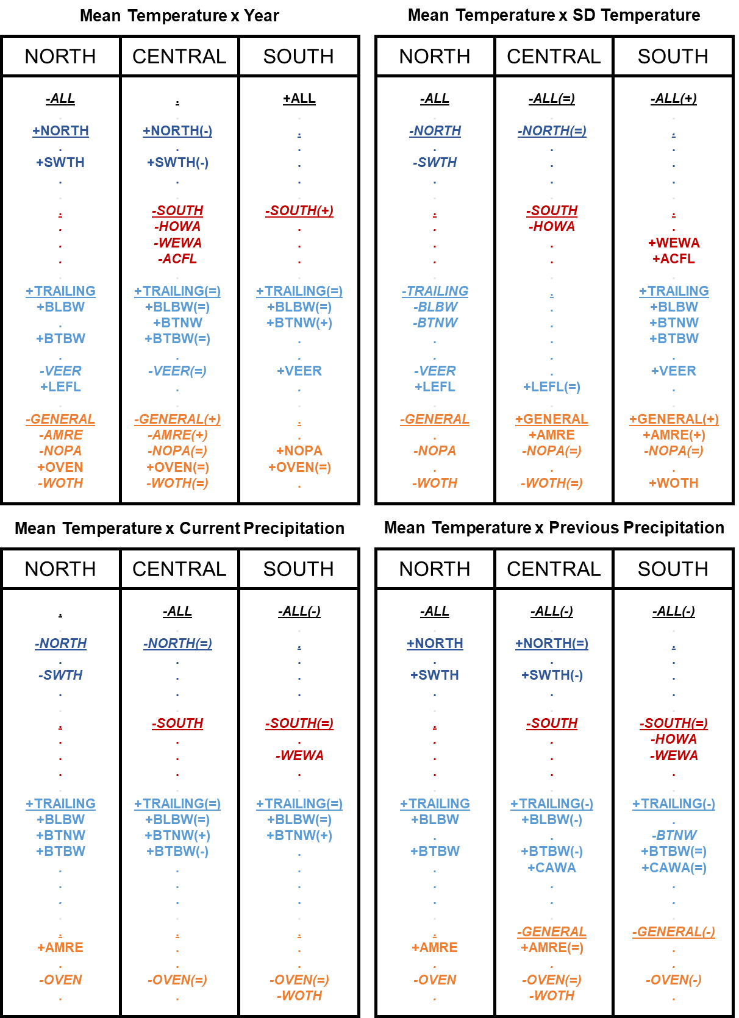

Figure 9. Compilation of combined results for the two-way interactions between year / SD temperature / current precipitation / previous precipitation and an index of latitude (i.e., mean temperature) for all guilds and focal forest songbird species. Because mean breeding season (i.e., 15 May to 30 June) temperature during the year of data collection was highly correlated with latitude, it was used as an index such that the north, central, and south groupings correspond to the mean breeding season temperatures across all sampling points in the Hubbard Brook Experimental Forest (14.3°C), Monongahela National Forest (16.3°C), and the 2 North Carolina National Forests (18.6°C), respectively. Guilds and species codes are color-coded and organized by guild designation (black = ALL = overall species richness, dark blue = NORTH = north guild, red = SOUTH = south guild, light blue = TRAILING = trailing guild, and orange = GENERAL = general guild); guilds are additionally underlined. Bold font indicates significance of the slope coefficients for the temporal or climate variables, whereas dots indicate non-significance. Positive slope coefficients are signified with a preceding plus sign, while negative slope coefficients are signified with a preceding minus sign and italicized font. The plus, equal, or minus symbol in the parentheses following the guild or species code indicates whether that slope coefficient was greater than, equal to, or less than the corresponding slope coefficient with the same sign (positive or negative) in the latitudinal grouping directly to the left.











Figure 10. Plots of the effects of the two-way interactions between elevation and the other predictor variables of interest (Table 2) on the median expected number of species (black line) belonging to each guild (see Appendix A for guild designations and associated forest songbird species), with 95% credible intervals (gray shading). The predictor variables are centered and scaled, such that zero is the mean value, and reflect the range of the data. Low, mid, and high elevation (elev) plots correspond respectively to 585.8 m, 844.3 m, and 1214.3 m, which are the 15th, 50th, and 85th percentiles of the elevation data across all sampling points.

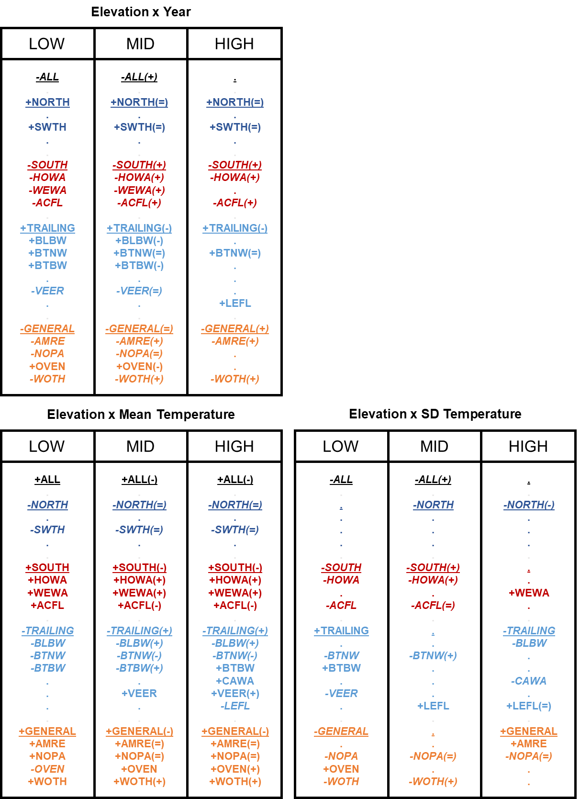

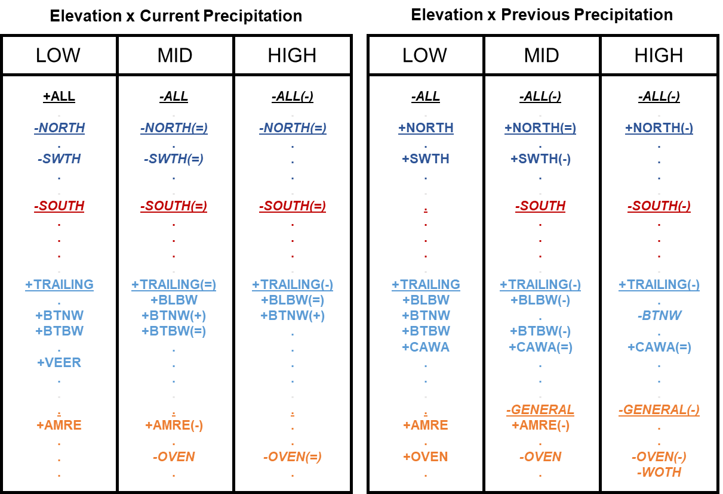

Figure 11. Compilation of combined results for the two-way interactions between year / mean temperature / SD temperature / current precipitation / previous precipitation and elevation for all guilds and focal forest songbird species. Low, mid, and high elevation groupings correspond respectively to 585.8 m, 844.3 m, and 1214.3 m, which are the 15th, 50th, and 85th percentiles of the elevation data across all sampling points. Guilds and species codes are color-coded and organized by guild designation (black = ALL = overall species richness, dark blue = NORTH = north guild, red = SOUTH = south guild, light blue = TRAILING = trailing guild, and orange = GENERAL = general guild); guilds are additionally underlined. Bold font indicates significance of the slope coefficients for the temporal or climate variables, whereas dots indicate non-significance. Positive slope coefficients are signified with a preceding plus sign, while negative slope coefficients are signified with a preceding minus sign and italicized font. The plus, equal, or minus symbol in the parentheses following the guild or species code indicates whether that slope coefficient was greater than, equal to, or less than the corresponding slope coefficient with the same sign (positive or negative) in the elevational grouping directly to the left.

****

****

















Figure 12. Plots of the three-way interactions between an index of latitude, elevation, and the other predictor variables of interest (Table 2) on the median expected number of species (black line) belonging to each guild (see Appendix A for guild designations and associated forest songbird species), with 95% credible intervals (gray shading). The predictor variables are centered and scaled, such that zero is the mean value, and reflect the range of the data. Because mean breeding season (i.e., 15 May to 30 June) temperature during the year of data collection was highly correlated with latitude, it was used as an index such that the north, central, and south plot rows correspond to the mean breeding season temperatures across all sampling points in the Hubbard Brook Experimental Forest (14.3°C), Monongahela National Forest (16.3°C), and the 2 North Carolina National Forests (18.6°C), respectively. Meanwhile, the low, mid, and high elevation (elev) plot columns correspond respectively to the 15th, 50th, and 85th percentiles of the elevation data across all sampling points within the Hubbard Brook Experimental Forest (north; low elev = 461.4 m, mid elev = 609.1 m, high elev = 773.1 m), Monongahela National Forest (central; low elev = 706.7 m, mid elev = 927.3 m, high elev = 1226.4 m), or the 2 North Carolina National Forests (south; low elev = 546.4 m, mid elev = 977.4 m, high elev = 1566.3 m).

































Figure 13. Plots of the three-way interactions between an index of latitude, elevation, and the other predictor variables of interest (Table 2) on the median expected count (i.e., abundance; portrayed by black line) for each of the focal species (Table 1), with 95% credible intervals (gray shading). The predictor variables are centered and scaled, such that zero is the mean value, and reflect the range of the data. Because mean breeding season (i.e., 15 May to 30 June) temperature during the year of data collection was highly correlated with latitude, it was used as an index such that the north, central, and south plot rows correspond to the mean breeding season temperatures across all sampling points in the Hubbard Brook Experimental Forest (14.3°C), Monongahela National Forest (16.3°C), and the 2 North Carolina National Forests (18.6°C), respectively. Meanwhile, the low, mid, and high elevation (elev) plot columns correspond respectively to the 15th, 50th, and 85th percentiles of the elevation data across all sampling points within the Hubbard Brook Experimental Forest (north; low elev = 461.4 m, mid elev = 609.1 m, high elev = 773.1 m), Monongahela National Forest (central; low elev = 706.7 m, mid elev = 927.3 m, high elev = 1226.4 m), or the 2 North Carolina National Forests (south; low elev = 546.4 m, mid elev = 977.4 m, high elev = 1566.3 m). Color of the 4-letter species code indicates its guild designation (dark blue = north guild, red = south guild, light blue = trailing guild, and orange = general guild), and the bird silhouette indicates its taxonomic family (warbler, thrush, or flycatcher).

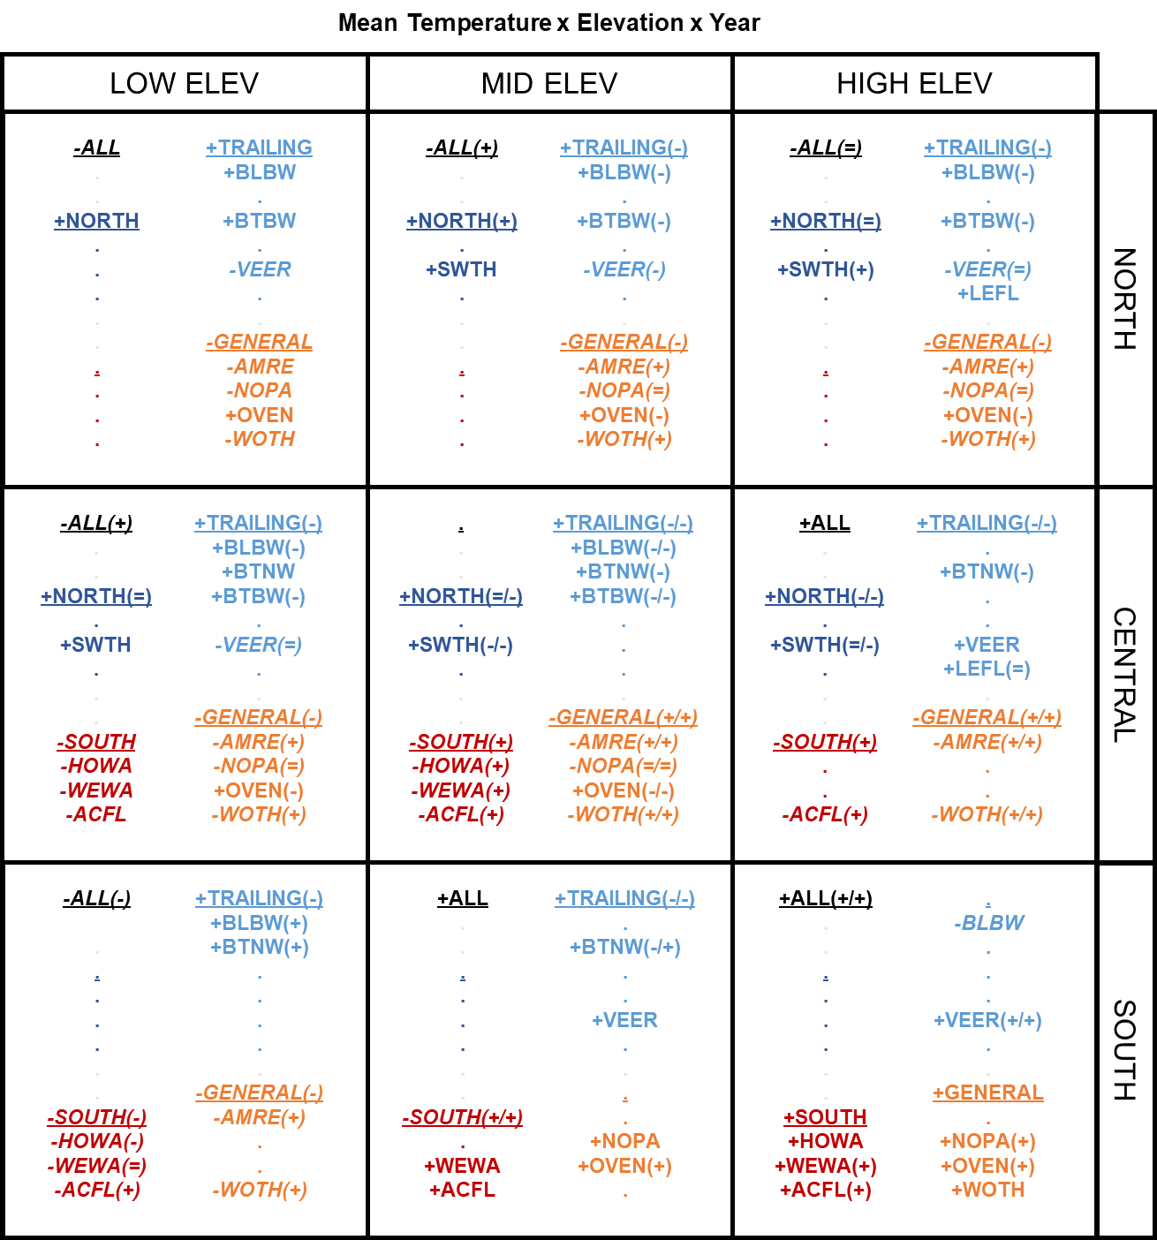

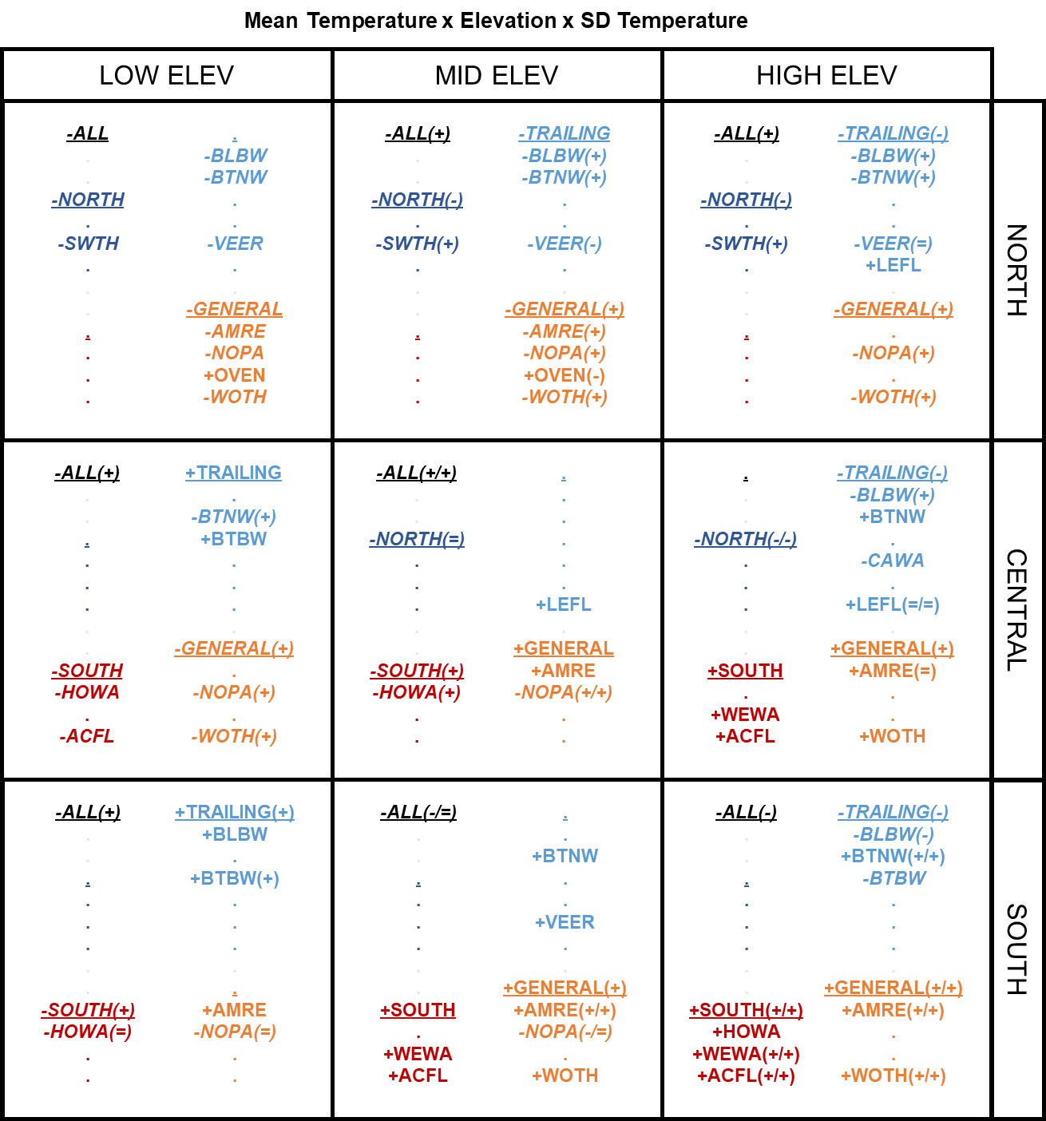

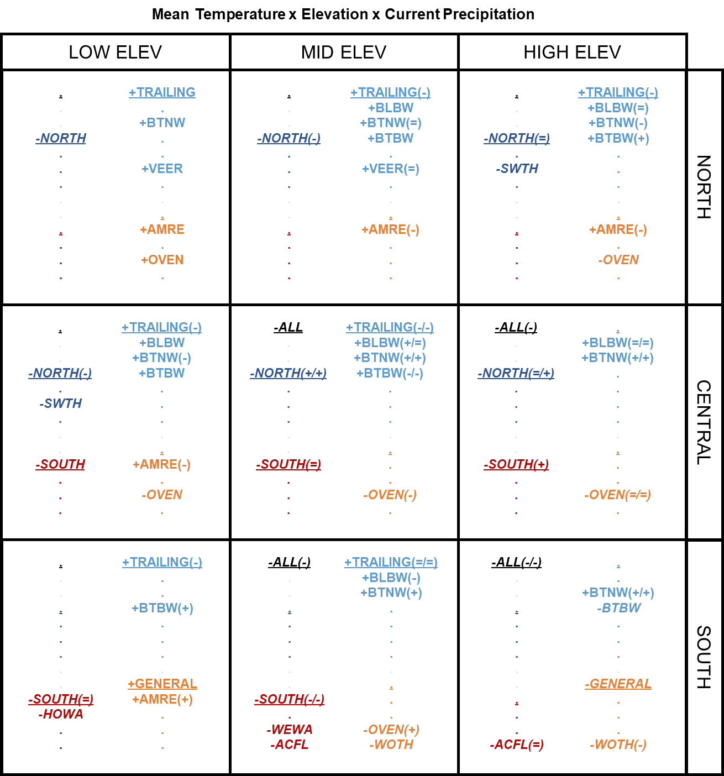

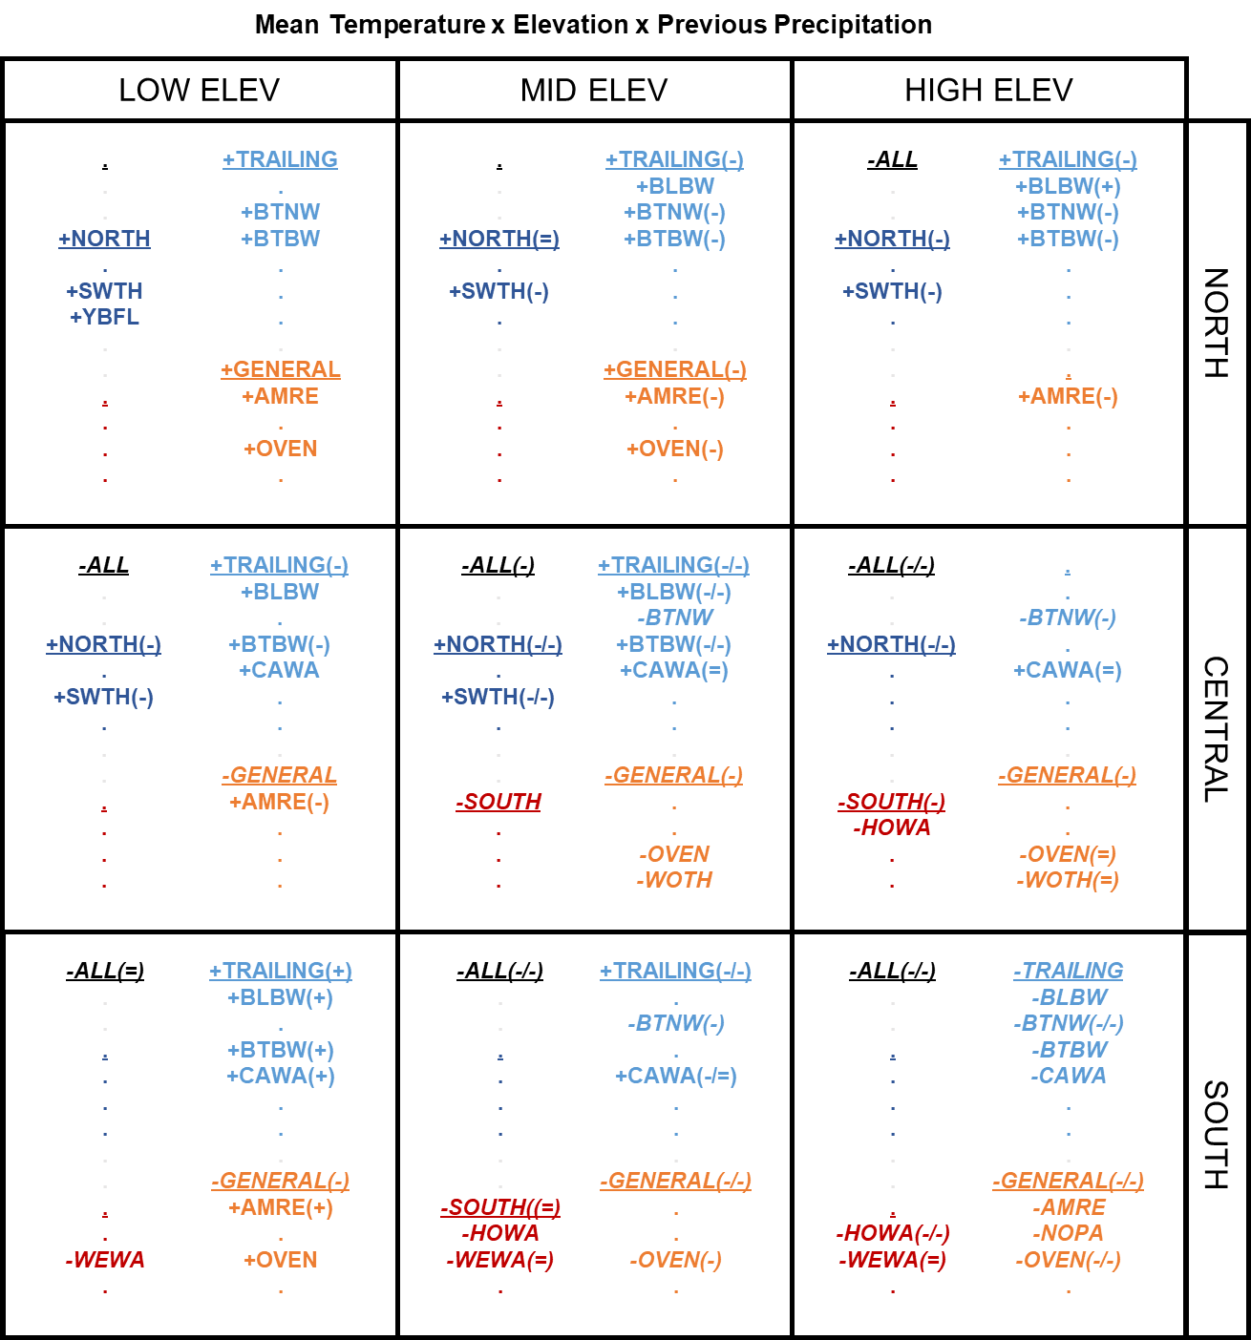

Figure 14. Compilation of combined results for the three-way interactions among an index of latitude, elevation, and year / SD temperature / current precipitation / previous precipitation for all guilds and focal forest songbird species. Because mean breeding season (i.e., 15 May to 30 June) temperature during the year of data collection was highly correlated with latitude, it was used as an index such that the north, central, and south plot rows correspond to the mean breeding season temperatures across all sampling points in the Hubbard Brook Experimental Forest (14.3°C), Monongahela National Forest (16.3°C), and the 2 North Carolina National Forests (18.6°C), respectively. Meanwhile, the low, mid, and high elevation (elev) plot columns correspond respectively to the 15th, 50th, and 85th percentiles of the elevation data across all sampling points within the Hubbard Brook Experimental Forest (north; low elev = 461.4 m, mid elev = 609.1 m, high elev = 773.1 m), Monongahela National Forest (central; low elev = 706.7 m, mid elev = 927.3 m, high elev = 1226.4 m), or the 2 North Carolina National Forests (south; low elev = 546.4 m, mid elev = 977.4 m, high elev = 1566.3 m). Guilds and species codes are color-coded and organized by guild designation (black = ALL = overall species richness, dark blue = NORTH = north guild, red = SOUTH = south guild, light blue = TRAILING = trailing guild, and orange = GENERAL = general guild); guilds are additionally underlined. Bold font indicates significance of the slope coefficients for the temporal or climate variables, whereas dots indicate non-significance. Positive slope coefficients are signified with a preceding plus sign, while negative slope coefficients are signified with a preceding minus sign and italicized font. The plus, equal, or minus symbols in the parentheses following the guild or species code indicate whether that slope coefficient was greater than, equal to, or less than the corresponding slope coefficient with the same sign (positive or negative) in the elevational grouping directly to the left (first symbol if 2 present) or in the latitudinal grouping directly above (second symbol if 2 present).